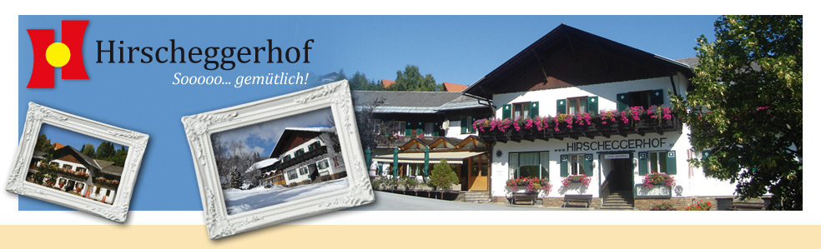
FAMILIE KINZER A 8584 Hirschegg 27
(+43)3141-2217 - www.hirscheggerhof.at

R O O M F A R E S

Bed and Breakfast Euro 42,--

Single rooms plus Euro 6,--

All prices per person and night!

sooo...good prices

you find on our homepage www.hirscheggerhof.at

For kids
in parents‘ room

Born 2008 and younger 30 %
Born 2014 and younger 50 %
Born 2017 and younger FREE

Valid from Nov. 1st 2019 to Oct. 31st 2020

